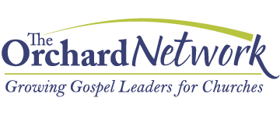

Residency
Experience

APPLICATION

The Orchard Network
1301 S. Grove Avenue
Barrington, IL 60010

Email residency@theorchardnetwork.org

INSTRUCTIONS

Please assemble the various components listed below into one completed application packet. Please do not send components individually.

Send completed application by email (preferred) to residency@theorchardnetwork.org. Or mail the completed application to Laura Eder c/o The Orchard Network, 1301 S. Grove Ave., Barrington, IL 60010.

- Fill out the application completely. Type (preferred) or print legibly. Some answers may require more than the allotted space; if so, use additional sheets of paper. Some questions may probe into areas that are uncomfortable for you. Be honest, transparent, and humble.

- Attach a recent photo of yourself.

- Include your resumé.

- Submit references from each of the following:

- a pastor or elder at your current church;
- someone who has served with you in ministry
- your spouse, if applicable (or close friend).

- Enclose three personal statements (pp. 9-11). One will explain your conversion experience; the second, your call to ministry; the third your philosophy of leadership. Each should be approximately one typed page.

- Attach/Enclose a sample sermon or talk as a CD, DVD, or online link. It should represent your best, most recent work.

A sermon or talk is preferred. However, if no sermon or talk is available, you can include a sample of a Bible study you led.

- Submit your packet by March 31st (for a January 1st intake) OR by October 31st (for an August 1st intake). Deadlines are subject to change.

When we receive your packet, it will be reviewed by leadership of The Orchard Network. You will be notified within one month as to whether you may proceed to the next step (formal assessment).

NOTE: Should your plans change and you would wish to remove your application from consideration, please notify us as soon as possible.
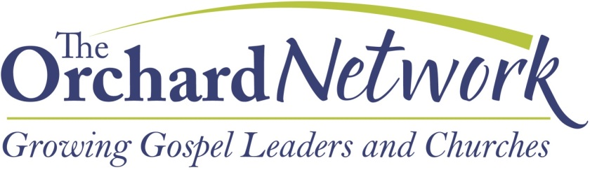
Attach/Embed a photo of yourself or family here:

GENERAL INFORMATION

Name (First Middle Last)

Street

City, State, ZIP

Home Phone ( )

Cell Phone ( )

E-mail Address

Date of Birth / / Place of Birth

Ethnicity

Gender Male Female Country of Citizenship

What is your first language?

Marital Status

Single Engaged Married Separated Divorced Widowed

Name of spouse or fiancé, if applicable.

If you (or your spouse) have ever been divorced, widowed, or a single parent, explain the circumstances on a separate sheet.

Anticipated intake cohort (circle one): January 1st _________ August 1st _________

Type of Residency Experience Desired: Full-Time __________ Bi-Vocational _________

Pastoral _________ Church Planting _________ Cross-Cultural Missions _________

The Orchard Network Residency Experience Application form is organized to assess your fit from four different “angles”:
- Character – general godliness, commitment to Christ
- Calling – strength and clarity of calling to be a full-time, long-term vocational pastor, church-planter or missionary
- Competence – ministry skills, ability, experiences
- Chemistry – personality, fit with The Orchard Network culture

CHARACTER

SPIRITUAL HISTORY

Were you raised in a Christian household? Yes No

When did you come to faith in Christ?

Have you been baptized? Yes No If so, when? _________________________

See Personal Statement #1(p. 9) – your conversion and spiritual journey.

PERSONAL CHARACTER

How would you assess your own character in light of the qualifications for pastors and elders in 1Timothy 3:1-7 and Titus 1:5-9?

If married, how would you assess your wife’s character in light of 1Timothy 3:11 and Titus 2:3-5?

An addictive behavior is one that has become more prominent in your life than you think is healthy, has had negative effects on you or your relationships, and which you have been unable to change or stop, despite more than one effort. Have you experienced addictive behavior with regard to: food, drugs, pornography, gambling, alcohol, etc. If so, please describe the situation and explain your current circumstances regarding it.

If admitted to the program, are you willing to be humble and transparent, so that others can hold you accountable for spiritual growth and change? Yes No

Describe your personal devotional life – particularly Bible reading and prayer.

CHURCH MEMBERSHIP

Name of Church

Senior Pastor __________________________________________________________________

Address ______________________________________________________________________

City, State, ZIP ________________________________________________________________

Phone ________________________________________________________________________

Website ______________________________________________________________________

Denomination Affiliation: ________________________________________________________
How long have you attended this church? ____________________________________________
Does your senior pastor know that you are pursuing this opportunity with The Orchard Network? Do you have his/her support? If not, please explain. (Note: If you are the senior pastor, do you have the support of your elder board chairman?)

CALLING

See Personal Statement #2 (p. 10) – your call to ministry.

How has your church affirmed your sense of call and your fitness for ministry? Have you been ordained? If so, by whom and when?

COMPETENCE

MINISTRY

Describe your spiritual gifts or ministry strengths.

What are some areas where you’d want to grow?

Have you participated in a short-term or long-term missions opportunity? If so, describe in a few sentences.

PREACHING/TEACHING

Briefly articulate your philosophy of preaching.

What is the relationship between the Word of God and preaching?

Who are some of your favorite preachers?

Sermon/Talk:

If you have a sermon or talk, please check one of the following:

_____ I have enclosed a sample sermon/talk

_____ Visit the following website:

Sermon/Talk Details:

Text _____________________ Theme_______________________

Setting/Audience/Comments about sermon/talk:

LEADERSHIP

See Personal Statement #3 (p. 11) – your philosophy of leadership.

What leadership roles have you had within the church? Para-church? Non-profit? Business?

CHEMISTRY

MOTIVATION

How did you learn about The Orchard Network Residency Experience?

Why do you want to train with us?

FAMILY

If married, how did you meet your spouse? How long have you been married? If you are engaged, when do you plan to be married?

How would you evaluate the strength of your marriage?

Do you have children? How many? What are their names and ages?

How do you cultivate a love for Christ in your household?

PERSONAL INSIGHT

Give the title of two books that have influenced you in ministry.

What do you and your family (if applicable) do for leisure?

EDUCATION
If educational experiences are not listed on your resume, please list all schools attended above high school, if any, here.

School | Degree/Major or Focus | Years attended

Have you had any other training experiences that we should know about?

FINANCIAL MATTERS

Each resident receives a stipend from The Orchard Network.

Does your spouse plan on working during the Residency Experience?

We expect each full-time Resident to raise $18,000 of his/her own support and each Bi-Vocational Resident to raise $9,000 of his/her support (The Orchard Network matches those amounts). Do you anticipate any problems here? Please explain.

Personal Statement #1
Describe your conversion experience, citing Scripture where appropriate. Briefly summarize your spiritual pilgrimage since conversion, mentioning significant experiences the Lord has brought into your life.

Personal Statement #2

Describe your call to ministry, specifically mentioning your call to be a pastor, church-planter or missionary. Briefly summarize the extent of your church involvement, listing ministries in which you have been active and experience you have had.

Personal Statement #3

Please articulate your philosophy of leadership. Share a situation where you led or influenced a group. Explain the situation, steps you took to address the situation, and the outcome.

REFERENCES

Submit three references.

Pastor/Elder at current church

Name Phone

Email

Someone who served with you in ministry

Name Phone

Email

Spouse (if applicable), or good friend

Name Phone

Email

Do you grant The Orchard Network permission to seek secondary references?

Yes No

PROGRAM REQUIREMENTS

The Orchard Network Residency Experience is a challenging program, requiring occasional travel and intensive engagement, focus, and diligence from participants. Are you confident before our Lord that you have the physical stamina, motivation and commitment to rigorous study and the desire for positive growth in character and ministry skills necessary to complete the curriculum?

Yes No

Do you grant The Orchard Network permission to perform a background check?

Yes No

The Orchard Network reserves the right to dismiss a resident who, in its judgment, does not conform to the standards established.

Applicant’s Signature Date

Note: Some of the questions and formatting for this application form have been gleaned from the ReGenerant Network Residency Application form. www.regenerant.org

